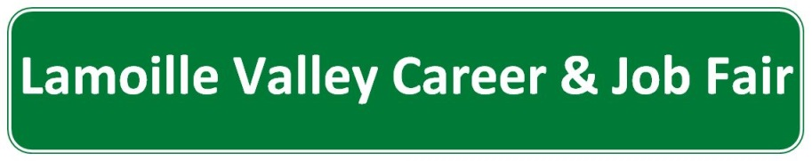

Vendor Survey

 | Strongly Disagree | Disagree | Agree | Strongly Agree
I found the date/time of the event appropriate for our calendar
Staff/volunteers were knowledgeable/helpful
The materials I received for the event prepared me adequately for the fair
Did you find the fair a cost effective way for you to recruit?
If your company has openings would you participate again next year
I was pleased with the number of resumes I received
I was pleased with the quality of resumes I received
I plan on offering a position to a job seeker I met at the fair
I plan on interviewing or following up with someone I met at the fair

How did you hear about the Job Fair?
Radio ☐
News Paper ☐
Direct Contact ☐ Name of person who contacted you _________________________
Other _________________________________________________________________

What are your top 2 suggestions for improving the Job Fair?

What do you think of the location and the venue?

Counting everything (communication, preparation, and event day) about how many hours did you contribute to the Job Fair?

So that we can evaluate the success of the job seekers portion of the fair, who can we contact in 30 days to see if you interviewed, seriously considered for employment and hired someone from the 2014 Lamoille Valley Career & Job Fair?

09/16/14

